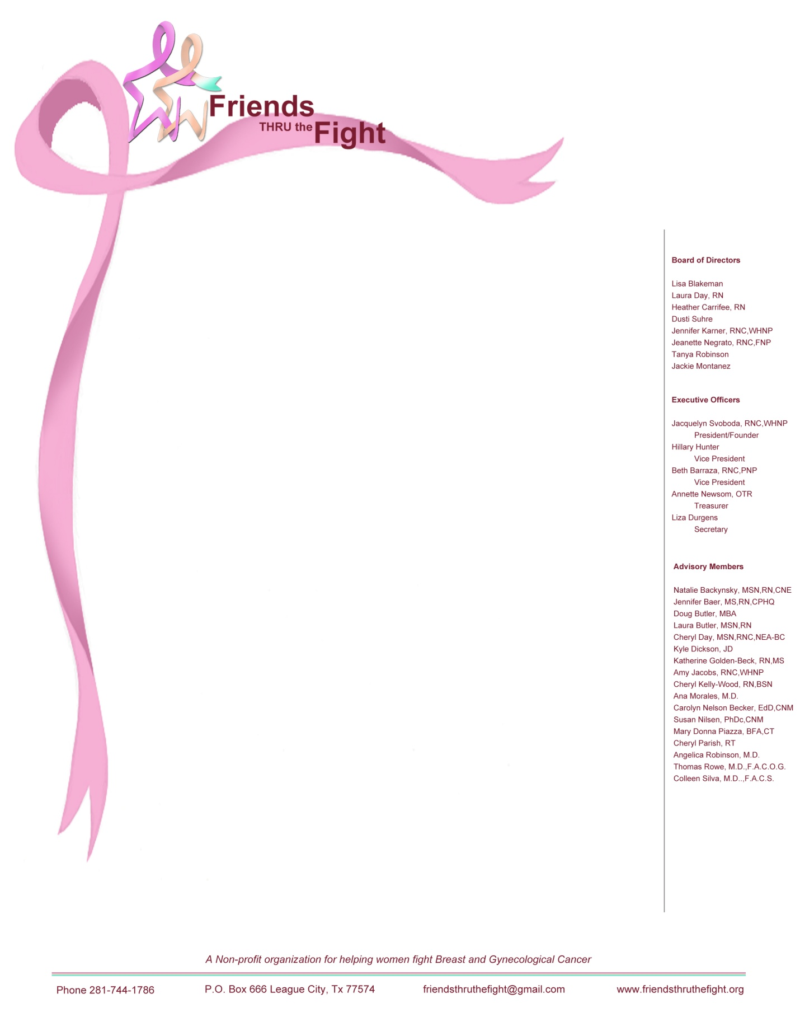

To Whom It May Concern,

I am very pleased to announce the Friends Thru The Fight (FTTF) 2nd Annual "Teeing Off With Friends" Golf Tournament, which will be hosted at Canon Gate @ Magnolia Creek on Thursday June 19, 2014. Over 120 golfers will join in the fun and festivities to raise funds to benefit FTTF and the patients we serve.

Friends Thru The Fight's mission is to serve Galveston County patients currently fighting breast or gynecological cancers by providing encouragement along with support services, meet emergent financial & spiritual needs. FTTF has distributed over $10,000 in support to woman and their families since August, 2012. We have coordinated and managed meal deliveries, distributed over 50 "Fight Bags" to local clinics and have spent countless time in fellowship with the patients we serve. Most recently we hosted a lovely "Patient Appreciation Luncheon" in March 2014 in which we provided educational presentations and time for networking between patients and families. All of this was possible through the success and donations received from the 2013 golf tournament.

Our one-day "Teeing Off with Friends" Golf Tournament includes dinner, golf, a fire & ice raffle and an auction. Your support of this tournament will allow us to continue to expand our outreach to patients, increase the monetary support we provide and build on the services already established. ***We respectfully request your assistance as a sponsor, player or in donating any gift contribution for a prize or auction item.*** Please see the Player Form and the Sponsor Application Form enclosed for more details.

Your contributions and registration fees may be made to the “Friends Thru The Fight," a 501c(3) non-profit organization, Federal Tax I.D. number is **45-4836339.**  All proceeds from the golf tournament will go directly to our mission and will help us serve patients & their families.

Sincerely,

Jacquelyn Svoboda

Founder, President Friends Thru The Fight, Inc